**Objective:** Implement Inheritance and Encapsulation.

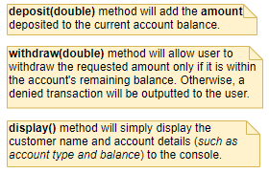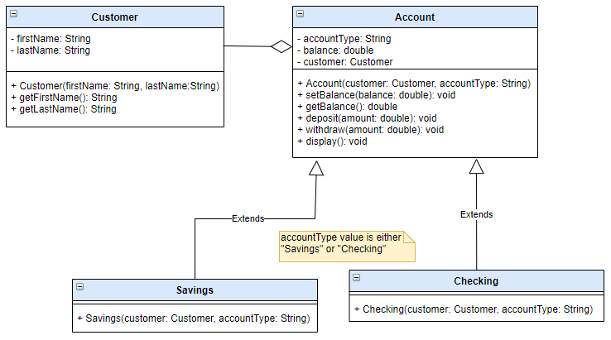

**Instructions:**

1. In your Java project, create your own package

2.Create the following classes based on the UML Class diagram:

**Customer**

**Account**

**Savings**

Sample Output:

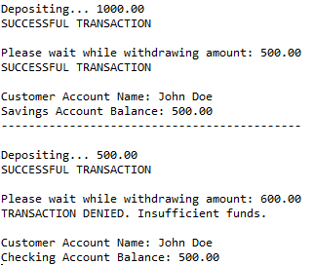

**Instructions:**

1. In your Java project, create a package.
2. Create the following classes based on the UML Class diagram:
   * Customer
   * Account
   * Savings
   * Checking

3. Create new class **AccountMain** that will contain the **main()** method and will perform the following:

* Create Customer object.
* Create instance of Savings account.
  + - Deposit 1000 to Savings.
    - Withdraw 500.
    - Display Savings account details.
* Create instance of Checking account.
  + Deposit 500 to Checking.
  + Withdraw 600.
  + Display Checking account details.